FULL STACK WEB DEVELOPMENT
<!DOCTYPE html>
<html lang="en">
<head>
<meta charset="UTF-8">
<meta name="viewport" content="width=device-width, initial-scale=1.0">
<title>This is first javascript page</title>
</head>
<body>
<h1 id="result"></h1>
<script>
let a = 23;
let b = 65;
let c = a + b;
// let a = 41;
// a = 57;
// document.write("after '+' assign = " + a);
document.getElementById("result").innerHTML = "After sum = " + c;
// document.write("after sum = " + c);
// const a = 10;
</script>
</body>
</html>

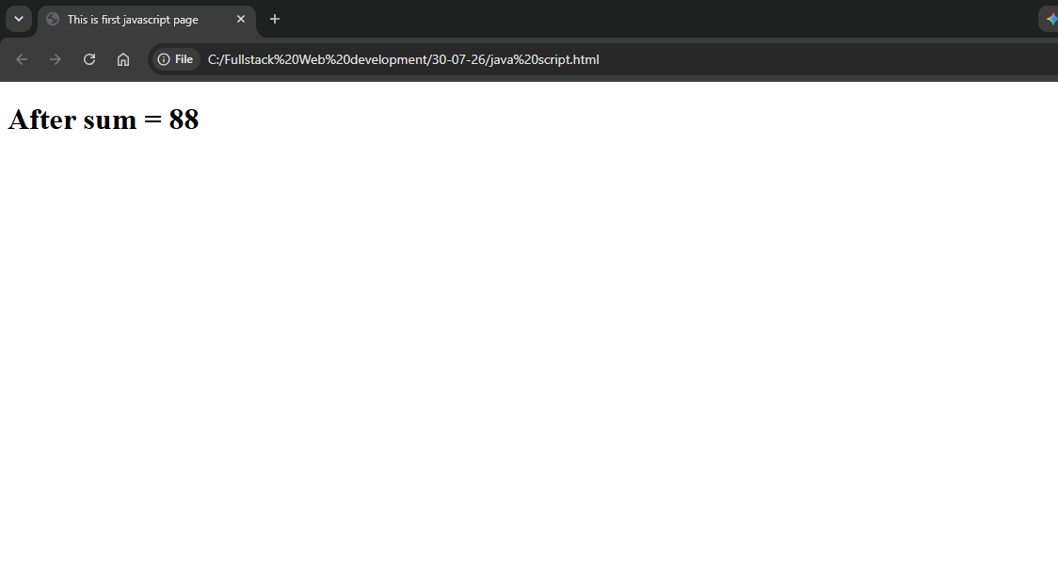
JAVASCRIPT -2
<DOCTYPE html>
<html lang="en">
<head>
<meta charset="UTF-8">
<meta name="viewport" content="width=device-width, initial-scale=1.0">
<title>This is first javascript page</title>
</head>
<body>
<h1 id="result"></h1>

<script>
let a = 23;
let b = 65;
let c = a + b;

a = 41;
a += 57;
document.write("after '+' assign = " + a);

//document.getElementById("result").innerHTML = "After sum = " + c;

// document.write("after sum = " + c);
// const a = 10;
</script>
</body>
</html>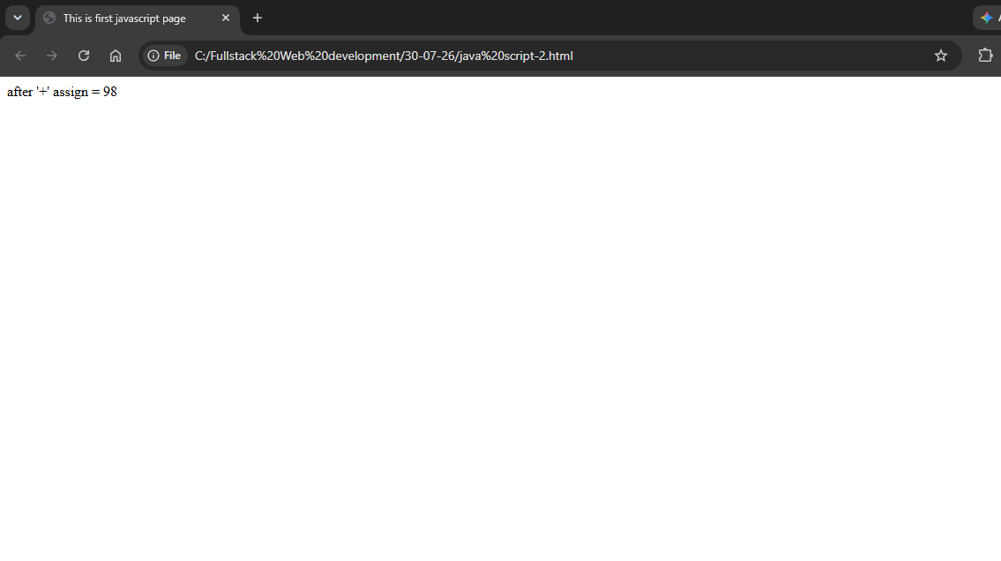
JAVASCRIPT-3
<!DOCTYPE html>
<html lang="en">
<head>
<meta charset="UTF-8">
<meta name="viewport" content="width=device-width, initial-scale=1.0">
<title>This is first javascript page</title>
</head>
<body>
<h1 id="result"></h1>

<script>
let a = 23;
let b = 65;
let c = a + b;

a = 41;
a += 57;
// document.write("after '+' assign = " + a + "<br>");

// document.getElementById("result").innerHTML = "After sum = " + c;

const x = 10;
const y = 20;
const z = x + y;
console.log("After sum: " + z);
</script>
</body>
</html>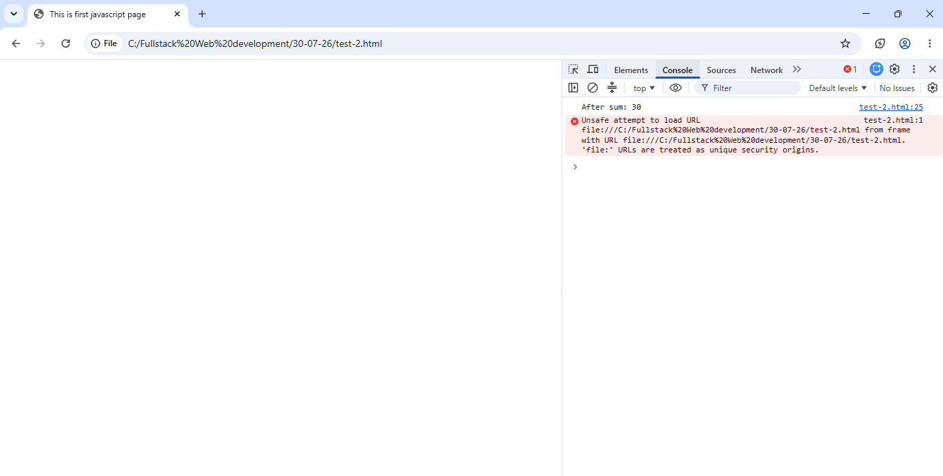

WHILECONDITION
<!DOCTYPE html>
<html lang="en">
<head>
<meta charset="UTF-8">
<meta name="viewport" content="width=<device-width>, initial-scale=1.0">
<title>whilecondition</title>
</head>
<body style="background-color: hsl(115, 70%, 53%); text-align: center; padding: 20px;">
<script>
let i=1;
while(i<10){
document.write(i +"<br>");
i++;
}
</script>
</body>
</html>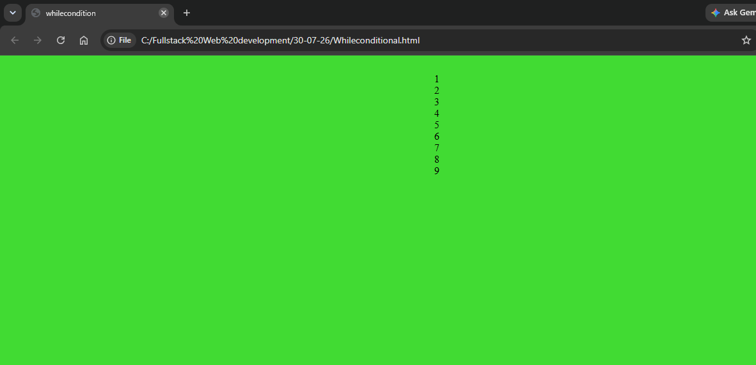

CONDITIONAL STATEMENT
JS
let a=12;
let b=15;
let c=11;
if(a>b && a>c) {
document.write("a is the largest number");

}
else if (b>a && b>c){
document.write("b is the largest number");
}
else if(c>a && c>b){
document.write("c is the largest number");
}
else{
document.write("all numbers are equal");
}
HTML
<!DOCTYPE html>
<html lang="en">
<head>
<meta charset="UTF-8">
<meta name="viewport" content="width=device-width, initial-scale=1.0">
<title>This is conditional statement page</title>
</head>

<body style="background-color: hsl(115, 70%, 53%); text-align: center; padding: 20px;">

<h2 style="color: brown;">Largest Number using if...else if</h2>

<script src="conditional.js"></script>

</body>
</html>